PERSONAL INFORMATION Prof. H.C. Prof. Dr. András NÁBRÁDI
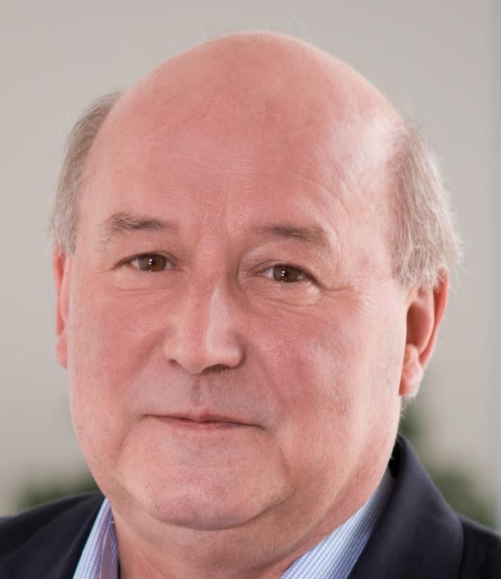
Poroszlay 111., 4032 Debrecen (Hungary)
(+36 30) 2491597
andrasnabradi@gmail.com, nabradi.andras@econ.unideb.hu

POSITION Professor and Head of Department of Business Economics at the Faculty of Economics and Business in University of Debrecen (UD), Hungary

Professor, Partium Christian University, Oradea, Romania, Faculty of Economics and Social Sciences,

WORK EXPERIENCE

05/01/1981–Present Research assistant, assistant professor, associate professor, finally university professor from 2000

University of Debrecen (UD), Debrecen (Hungary)

Education and research
Lecturing subjects at the fields of business management, strategic planning, business planning, project management, risk management, research in applied economics, family business, especially in agribusiness.
Guidance and assistance of PhD candidates and graduate students’ theses

Positions:
- head of department 1999-, Department of Business Economics at Fac.
- head of institute (2014-2018), Institute of Applied Economics
- vice rector (2013-2015) of Strategic Affairs in University of Debrecen
- dean (2002-2013) of the Faculty of Applied Economics and Rural Development
- director (2000-2002) of the Institute of Agribusiness and Rural Development at UD
- dean (1997-2000) of the Faculty of Agricultural Sciences
- vice dean (1994-1997) of science at the Faculty of Agricultural Sciences

2013–Present Professor

Partium Christian University, Oradea (Romania)
Teaching at the field of strategic management and business planning, conducting thesis work for BA and MA students.

2005–2010 Professor

Szent István University, Gödöllő (Hungary)
Strategic partner of the dean of Faculty of Economics and Social Sciences. Education and research at the field of applied economics in BA, MA level.

1980–1981 Agronomist

Zagyvavölgye Co-operative, Homokterenye (Hungary)
Conducting animal husbandry branch at the co-operatíve

EDUCATION AND TRAINING

1975–1980 Agronomist (Agricultural Engineer) MSc equivalent level

Debrecen Agricultural University, Debrecen (Hungary)

1982–1984 Doktor univ. in econ. EQF level 7

Debrecen Agricultural University, Debrecen (Hungary)

1987–1993 Candidate (CSc) in economics EQF level 8

Hungarian Academy of Sciences, Budapest (Hungary)

1991–1993 MBA Master of Business Administration

Debrecen Agricultural University & International Consortium, Debrecen (Hungary)

1998–1998 PHD, in econ. EQF level 8

Debrecen Agricultural University, Debrecen (Hungary)

1998–1999 Doctor habil. EQF level 8

Debrecen Agricultural University, Debrecen (Hungary)

PERSONAL SKILLS

Mother tongue(s) Hungarian

Foreign language(s) | UNDERSTANDING |  | SPEAKING |  | WRITING
 | Listening | Reading | Spoken interaction | Spoken production
English | C1 | C2 | C2 | C2 | C1
Russian | B1 | B1 | B1 | B1 | B1
Levels: A1 and A2: Basic user - B1 and B2: Independent user - C1 and C2: Proficient user Common European Framework of Reference for Languages

Organisational / managerial skills National and international professional scientific activity:
Member of the Public Body of the Hungarian Academy of Sciences (HAS)
Chair of the Ag. economics Committee of the Agricultural Division of the HAS, in Debrecen Executive Board member of the International MBA Network ‘AGRIMBA’ (2000-2015) Elected president of European Society of Agronomy (2010-2012)
Elected president of the Hajdú-Bihar County Division of Hungarian Association of Economists (2014-) Co-president of the Hungarian Functional Food-chain Production Council (2014-)
Member of the Council of Hortobagy National Park (2005-2009)
Editorial Board Member of: Hungarian Dairy Journal, Hungarian Journal of Food Nutrition and Marketing (Hungary), Delhi Business Review (India), Economics of Agriculture (Serbia), The Annals of the University of Oradea Economic Sciences (Romania), Economic and Regional Studies (Poland), NUML International Journal of Business & Management (Pakistan) Deputy editor of: Applied Studies of Agribusiness and Commerce APSTRACT (Hungary, Debrecen)

Job-related skills Foreign lectures upon invitation :
Wageningen University, the Netherlands (1993, 1995, 2003, 2004, 2005, 2006) University of Udine, Italy (1998)
Obihiro University, Japan (1992) Iowa State University USA, (1994)
Hohenheim University, Germany (1996, 2000)

Zagreb University, Croatia, (2006, 2007, 2013, 2014, 2015, 2017, 2018) University of Novi Sad, Serbia (2007)
University of Belgrade, Serbia (2008, 2009)
National Agricultural University, Belgorod, Russia (2017, 2020)
Visiting professor at Mediterranen University Montenegro, Podgorica (2011-

Prizes, awards in sciences:

Széchenyi Grant of Professors (Hungary), 1998 UN-FAO Prize, 2006, 2009
Master teacher 2007, National Science Student Council, Hungary
Award For Hungarian Higher Education, 2008, Ministry of Higher Education and Culture For Agricultural Research in Debrecen 2008, University of Debrecen
Újhelyi Imre Award, Ministry of Agriculture and Rural Development, Hungary
2009 Knight's Cross Order of Merit of the Republic of Hungary, 2009
Honoris Causa Professorship 2010, Delhi School of Professional Studies and Research Lifetime Achievement Award 2011 Delhi School of Professional Studies and Research Pro Cura in Genii Award from University of Debrecen 2011
Pro Auditoribus Universitatis Debreceniensis Award 2013
Commemorative plaquette of Hungarian Academy of Sciences, Debrecen Division 2015
Commemorattive plaquette of UNIDEB, Faculty of Agricultural and Food Sciences and Environmental Management 2018
Kádár Béla Award from University of Debrecen, Faculty of Economics and Business, Hungary 2019

Digital skills SELF-ASSESSMENT

Information processing | Communication | Content creation | Safety | Problem solving
Proficient user | Proficient user | Proficient user | Independent user | Proficient user
Digital skills - Self-assessment grid

ADDITIONAL INFORMATION

Publications All publication is 543 out of which scientific 446. Independent citation is 815, total number of citation is 1116. Hirch index 13.
(https://m2.mtmt.hu/gui2/?type=authors&mode=browse&sel=10000014&view=pubTable)

Conferences From 2003 every two year (bi-annually) organize AVA Conference and from 2009 AVA-AGRIMBA Congress in different countries (Hungary 2009, Netherlands 2011, Montenegro 2013, Croatia 2015, Hungary 2017 and Mongolia 2019). http://www.ica-agrimba.eu/index.php. Also organize The Partium International Conference on Management from 2019
Upon this, he started for organizing Tourism and Sport Management Conference from 2010, and member of scientific board of several conference in Europe.

Establishment and operation of a
scientific journal
He initiated in Aberdeen (Scotland) in 2005 at the International MBA Network Executive Board Meeting for establishing a "common valuable journal", than the first issue of the "APSTARCT" scientific journal was published in 2007. In 2019 has been the thirteenth edition will appear in the journal, in which he is still the deputy editor of chief. (www.apstarct.net)
Initiating and implementing double - degree diploma training:
Since 2005, he has entered into a double degree diploma contract with Wageningen University in the Netherlands, later with the University of Applied Sciences in Jyvaskyla, Finland, in 2017 with the University of Applied Sciences of Mongolia at Ulaan Baator. The same dual diploma training is in preparation for the Mediterranen University in Montenegro. In each case, Business Development MSc is in Hungary and some kind of MBA education in partner countries is the basis for cooperation.

Foundation and operation of
BSc/MSc courses
Since 2004 he has been an initiator of several BSc, BA and MSc programs, currently he leads the MSc in Entrepreneurship Development at the University of Debrecen, Hungary

